**REPORT DOCUMENTATION**

Procedure Experiment

Date: October 12, 2022

Writer: Heru

**Contents:**

1. **Pre-Experiment**

* Propose
* Time and Location
* Hardware
* Software

1. **Post Experiment**

* Datasets
* Documentation

**Pre-Experiment**

This experiment was carried out to collect vehicle-plate datasets in front of the entrance of traffic gates for vehicles such as cars and motorbikes as a parking area in the campus area. Before conducting experiments or stages that must be met, where, this stage serves to prepare all the tools that will be used during the dataset retrieval experiment. Such as several process below:

* Propose

This dataset will be taken using 1 camera holder mounted on a pole with a height of 3 meters. This configuration includes camera calibration and network settings on the Raspberry Pi. The purpose of this experiment is to get 2 views, namely inside (front) and outside (back), where the display will detect the vehicle plate automatically on an ongoing basis, and the resulting data can be used for the analysis of the methods used in the future.

* Time and Location
* Date Time: ….. , 06:50 Am - 10:00 Am
* Location: The front gate of the Ming Chi University of Technology campus.
* Hardware Used
* 1 Raspberry Pi
* 1 Entaniya fisheye camera
* LAN cable (4 meters)
* Tripod + Camera phone (documentation)
* Laptop
* Software Used
* Laptop with Ubuntu 20.04
* Monitoring System Application

**Post Experiment**

This process is divided into two stages. The first stage is the resulting dataset. The second stage is documentation during the data collection process, which involves implementing the analysis and design of the previous dataset retrieval position.

* Experiment

Using 1 entaniya fisheye camera attached to other components. Before doing the actual work, we designed how to place the camera position and the area around the dataset capture area, as shown below.

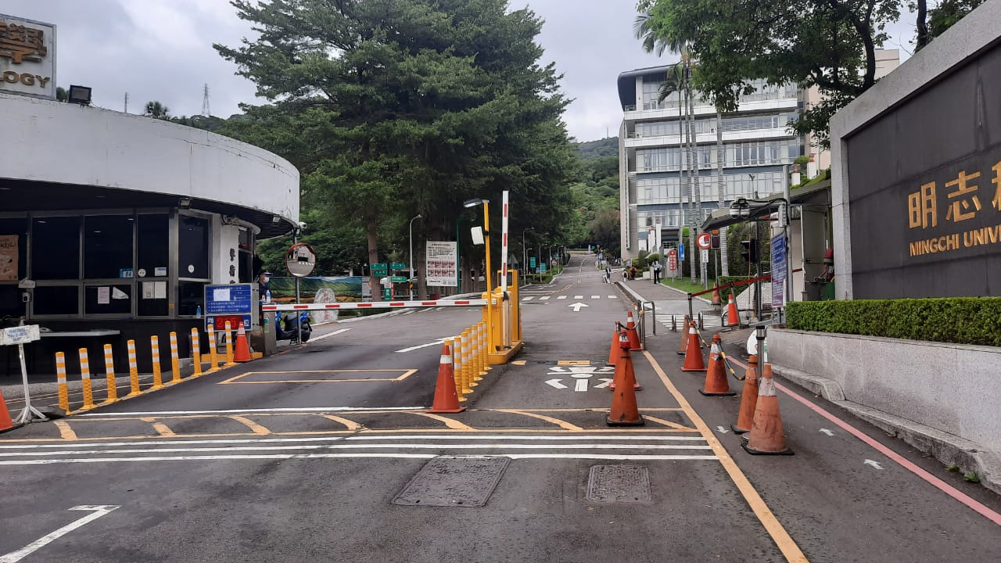

Figure 1. Inside (Front)

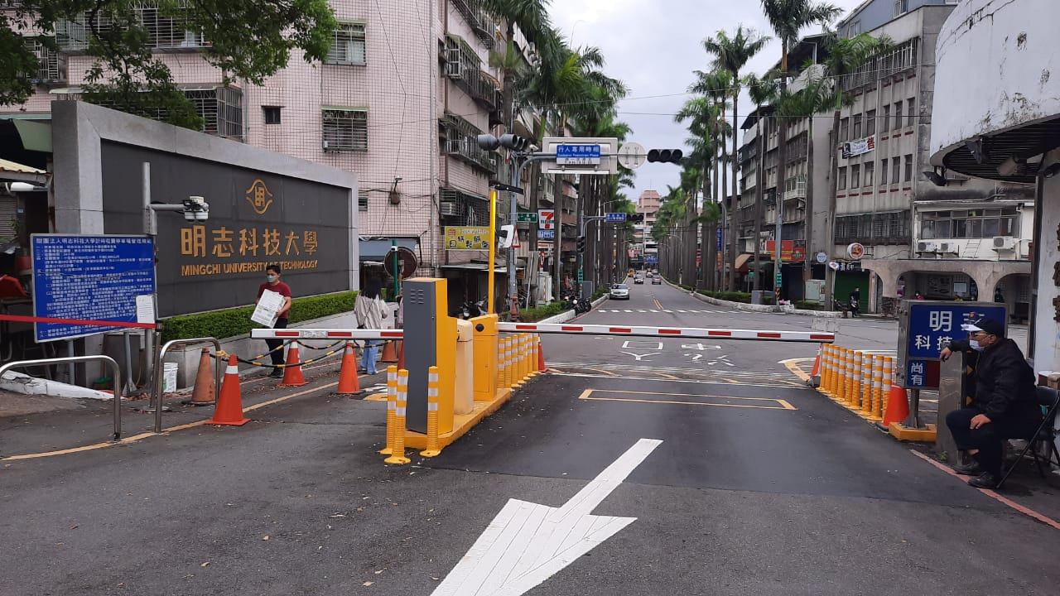

Figure 2. Outside (Back)

* Result datasets

Implementing the procedures described in this document calls for modelling using one camera when taking outdoor datasets (MCUT). To prove that the data set has been collected, click this link to view the results.

* Documentation

Over here, we attach some of the documentation that we took during the dataset retrieval process.